**Worksheet**

**EXPERIMENT – 6**

**GROUP NUMBER: 3**

|  |  |  |
| --- | --- | --- |
| **S. No** | **Student Name** | **UID** |
| **1** | **Sahul Kumar Parida** | **20BCS4919** |

**Aim:**

Create an artificial intelligence powered ChatBot to mimic human interactions for e-commerce.

**Requirements:**

PC with internet connectivity, Python 3.7

**Expected Outcome:**

**Chatbot**

A chatbot is a computer program that simulates conversation with human users to complete some sort of service.

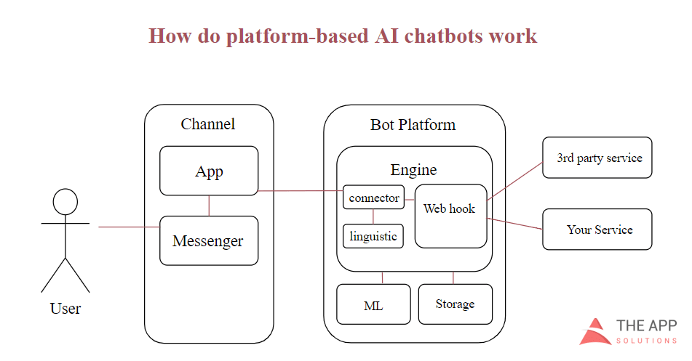

Figure 1: Workflow in sentiments detection

Chatbots for ecommerce companies are typically designed to:

* Complete buyers’ purchases
* Offer buyers product recommendations
* Provide customer support

**The Types of Chatbots for E-Commerce**

**Script Bots**

This is the simplest type of chatbots. Such bots operate on the base of predefined commands or scripts. They are programmed to recognize some words and answer basic questions. Nowadays, this is the most popular type of e-commerce chatbots. However, they aren't very flexible. Some online shops integrate bots with Natural Language Processing (NLP) technology to make interactions with customers more natural.

**Smart bots**

These chatbots are powered by AI (Artificial Intelligence). They provide more positive user experience since they interact with customers in a human-like way. Still, such bots are not perfect. Their work is not fully automated, and they need human intervention to be able to answer specific customer inquiries.

**Intelligent Agent**

This is the most advanced type of chatbots. They combine machine learning and AI technologies, which makes them entirely self-sufficient. The great examples of such bots are Amazon’s Alexa, IBM Watson, and Siri.

**Define E-Commerce Chatbot Features**

On this stage, we need to decide the purpose of our future chatbot since there are many options. Our future chatbot could perform as:

* Product finder
* Order status checker
* Customer service provider
* Offer notifications
* Personal shopping assistant

Alternatively, all of these purposes can be used in one chatbot since this technology has endless business use cases.

Below we share the most popular tasks performed by a chatbot on e-commerce websites.

* Collect customer data
* Advertise and broadcast
* Handle online transactions
* Send notifications and reminders
* Provide access to information
* Upsell products
* Conduct market research by offering a quiz
* Give personalized recommendations
* Collect customer data and user feedback
* Provide customers support
* Automate business process

**Commands:**

**https://dashboard.chatfuel.com/bot/5fad2ff427306d6b46523b59/grow**

1. **Welcome Message**

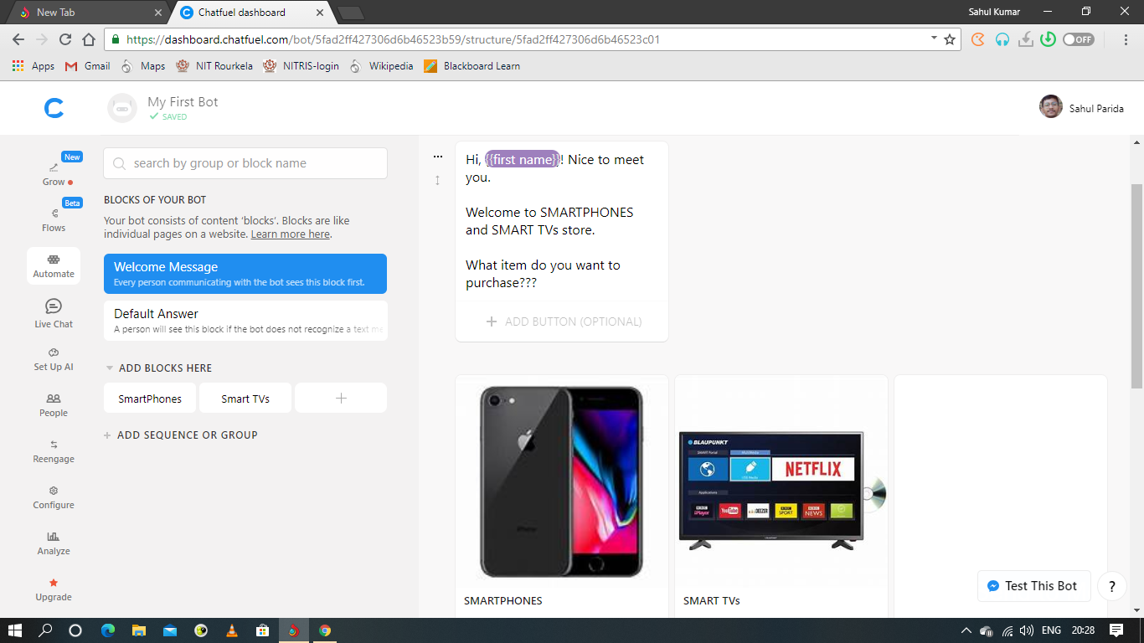

1. **Setting up AI**

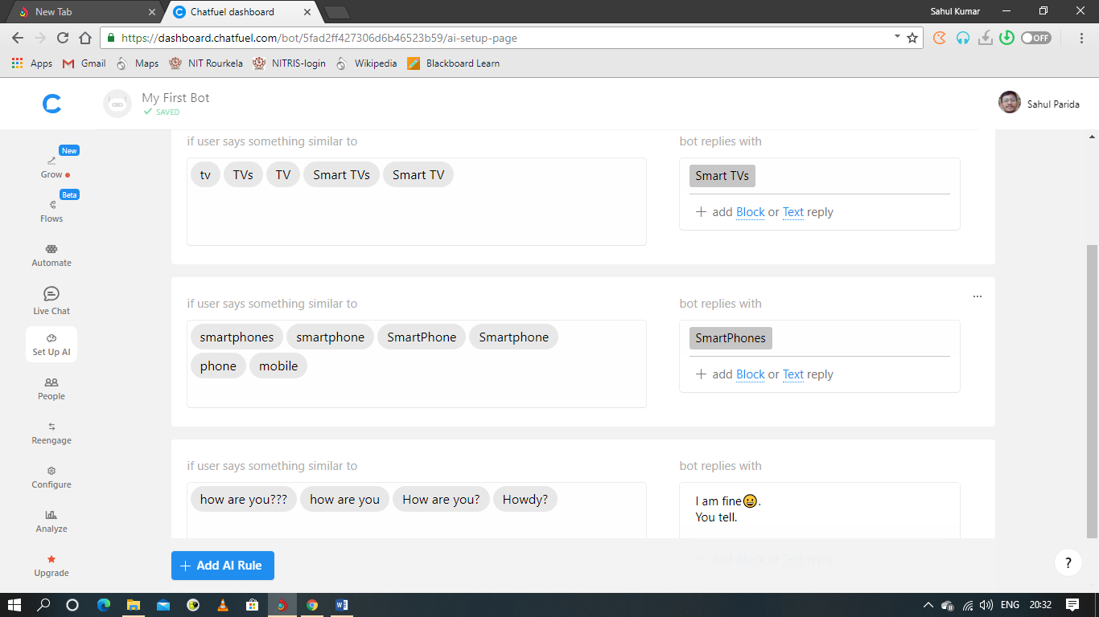

1. **Adding Blocks**

BLOCK SMARTPHONE

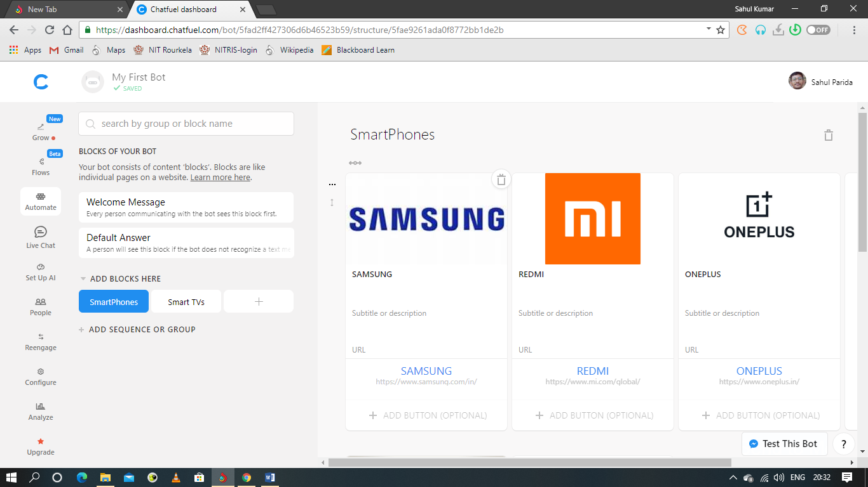

BLOCK SMART TVs

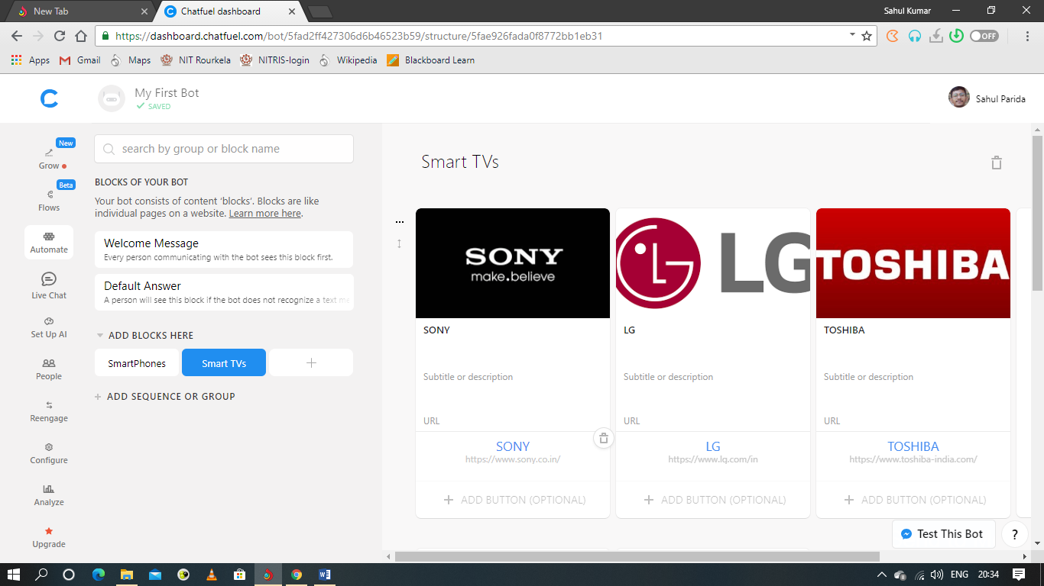

**Output:**

**TESTING THE BOT**

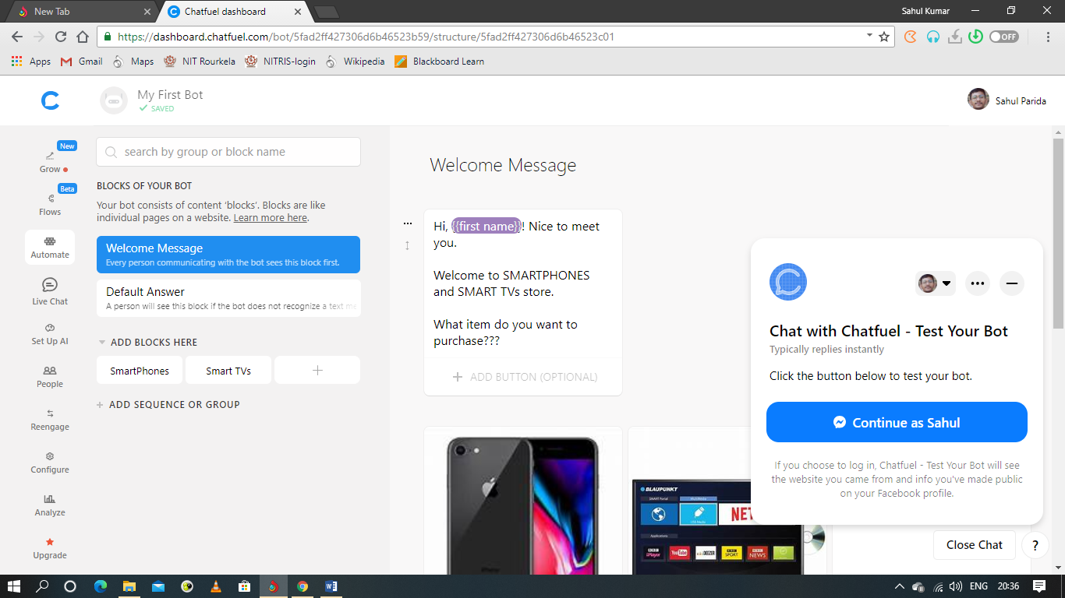

User gets to choose either SMARTPHONES and SMART TVs as per their choices.

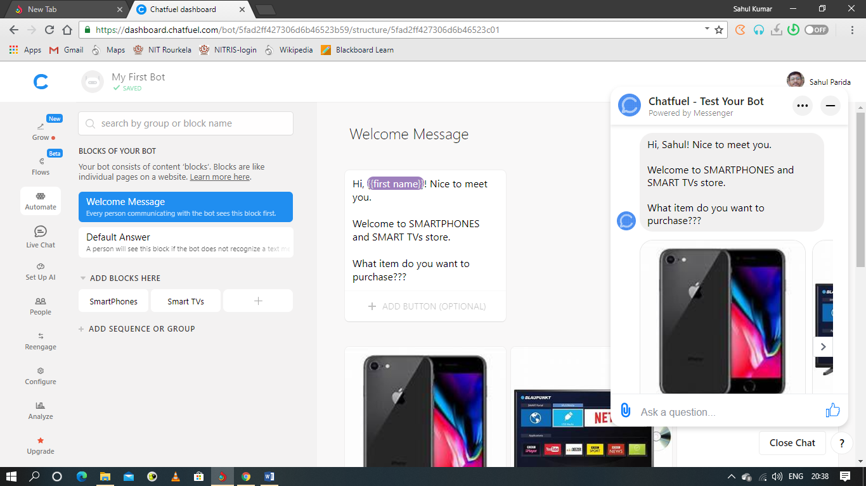

SMARTPHONES

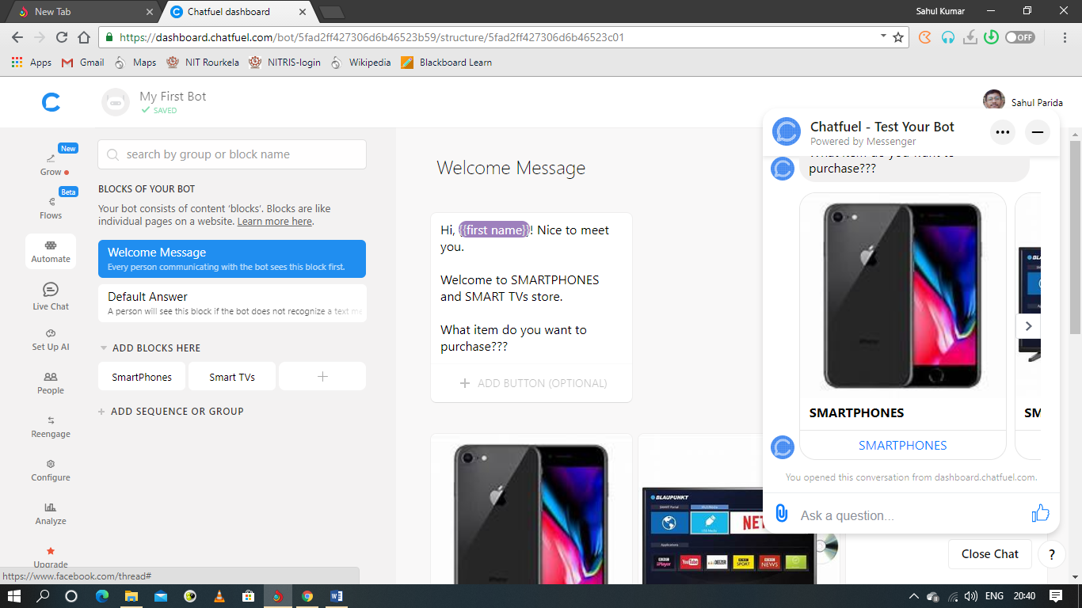

SMART TVs

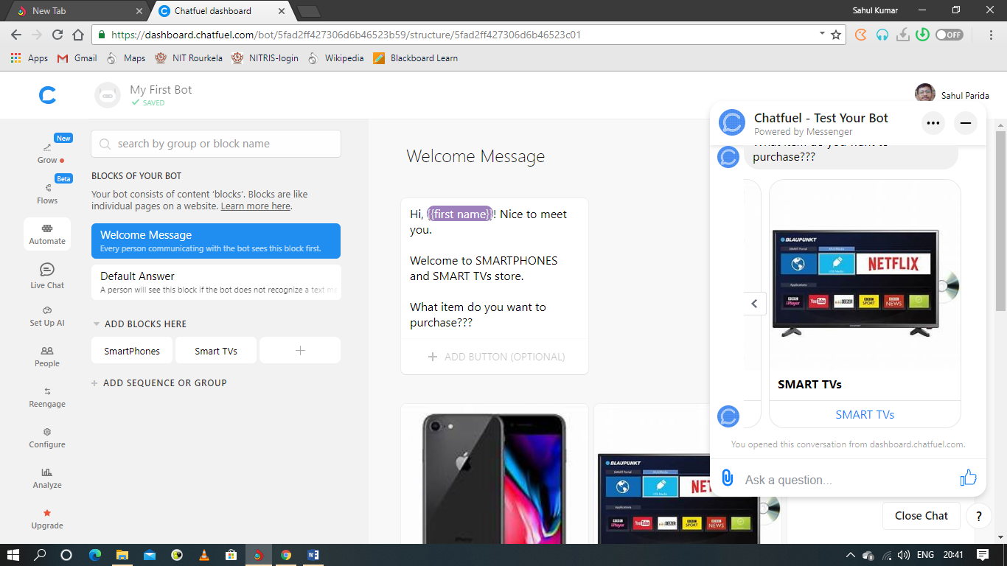

When user clicks SMARTPHONES-

User gets to select the brands SAMSUNG, REDMI, ONE PLUS, APPLE.

1. SAMSUNG

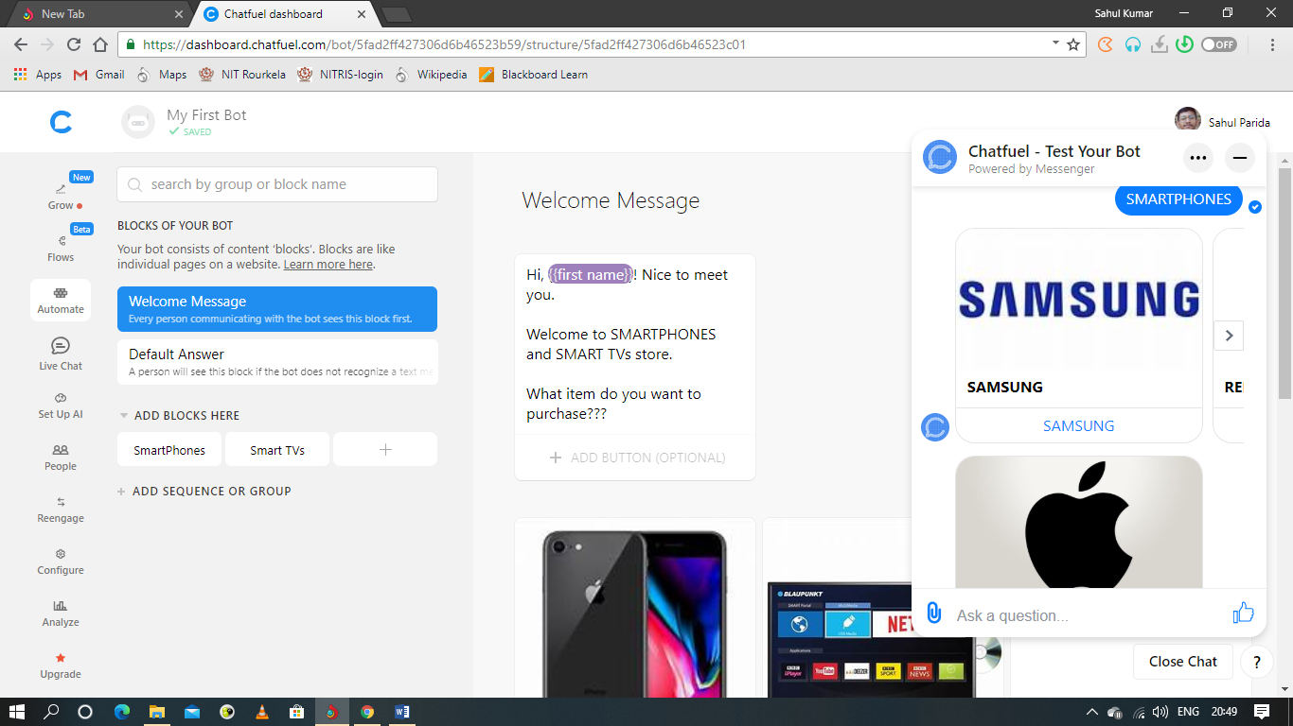

If user clicks SAMSUNG, it gets redirected to SAMSUNG official website.

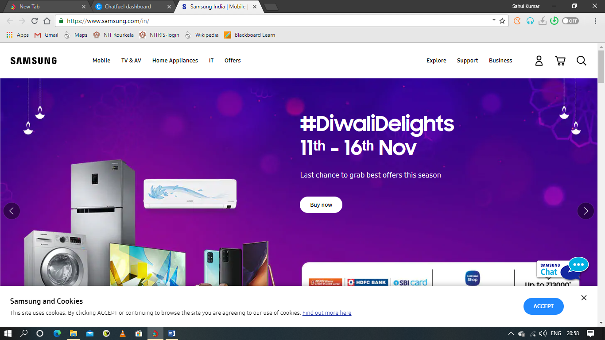

1. REDMI

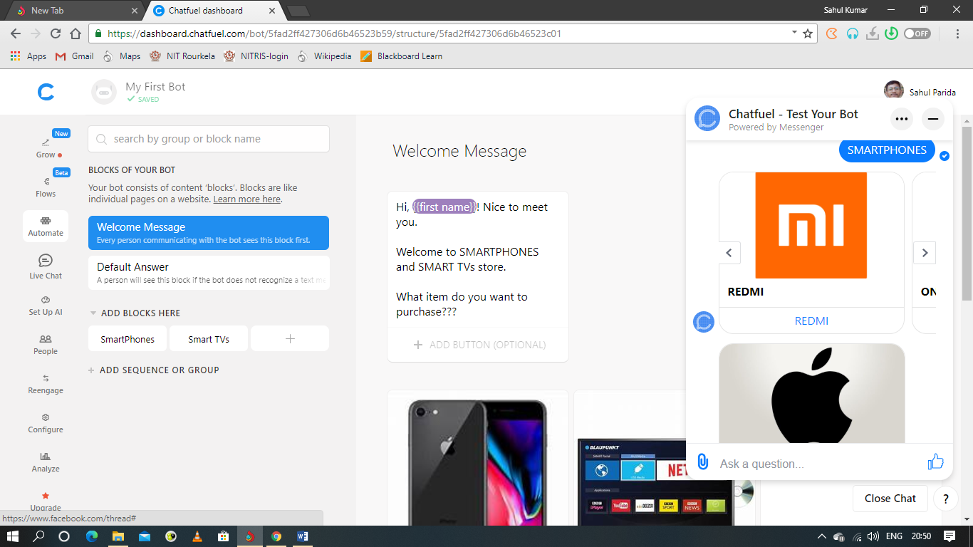

If user clicks REDMI, it gets redirected to REDMI official website.

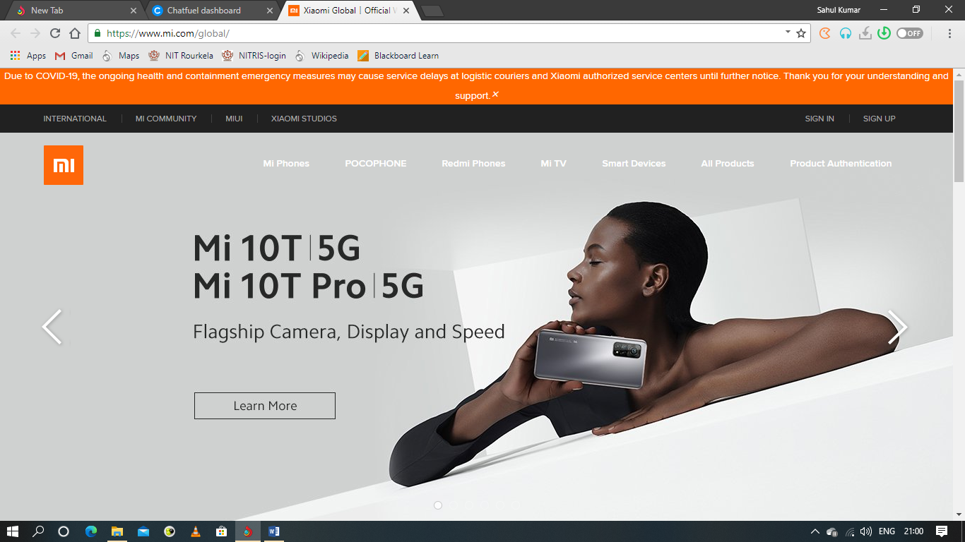

1. ONE PLUS

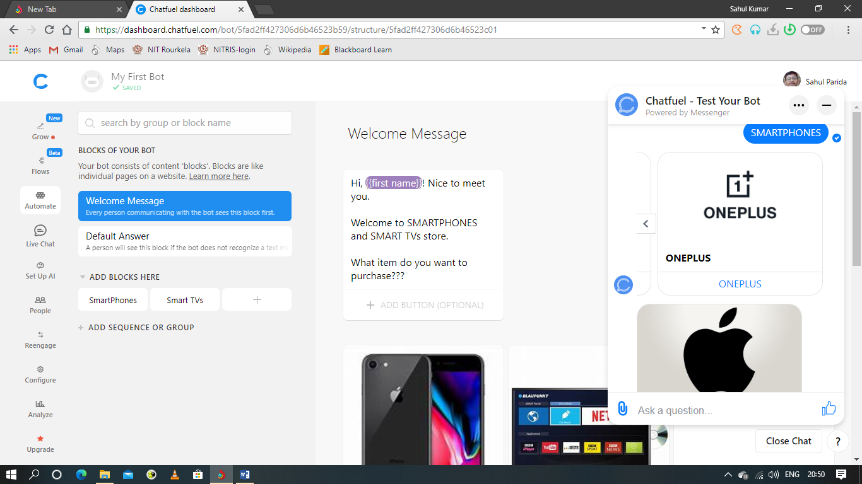

If user clicks ONE PLUS, it gets redirected to ONE PLUS official website.

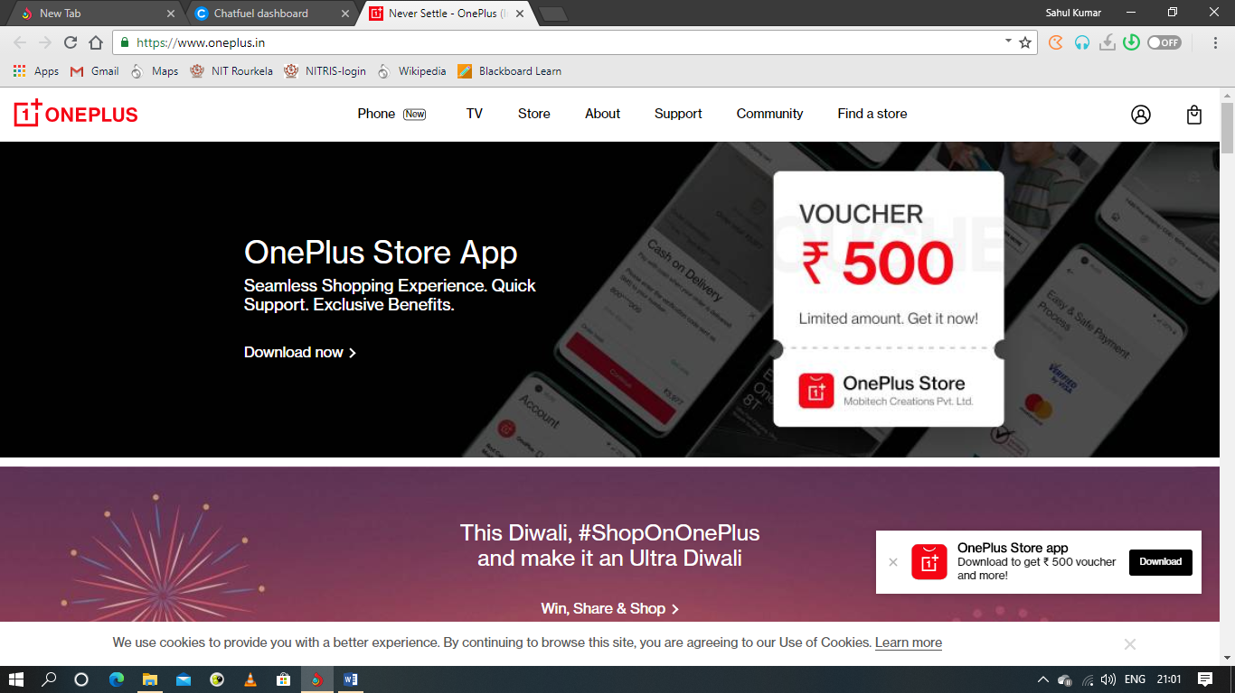

1. APPLE

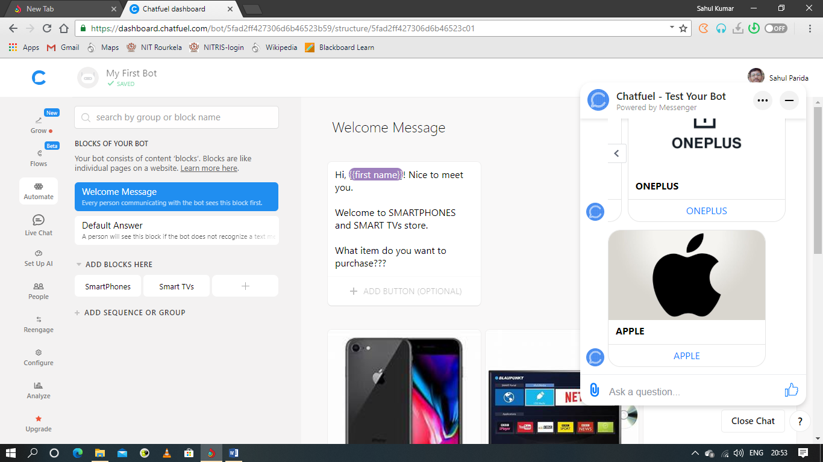

If user clicks APPLE, it gets redirected to APPLE official website.

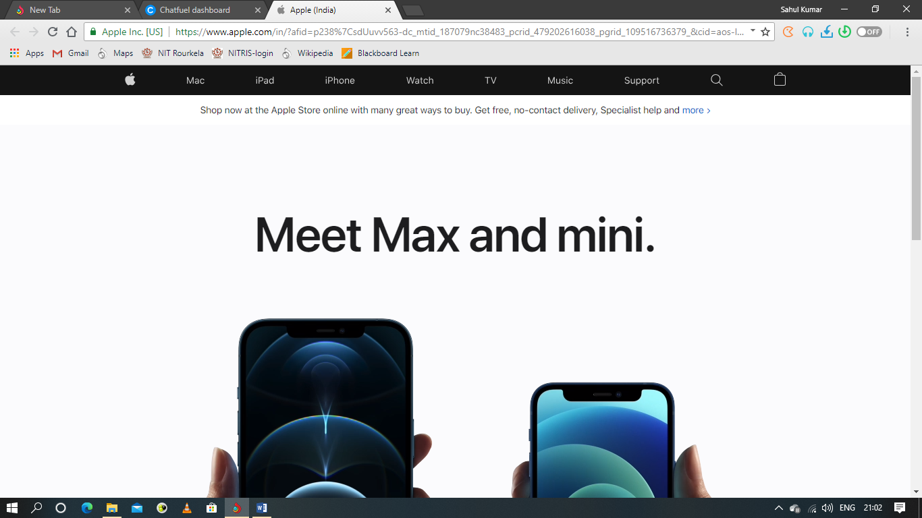

When user clicks SMART TVs-

User gets to select the brands SONY, LG, TOSHIBA, RELIANCE.

1. SONY

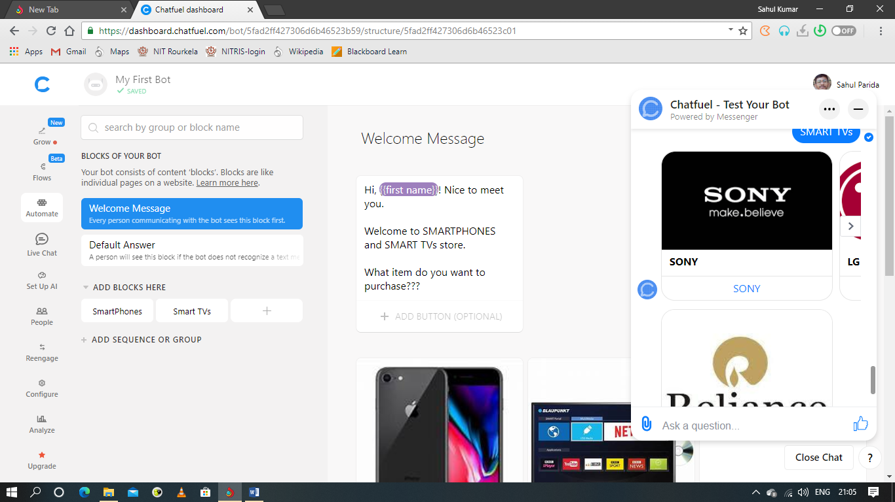

If user clicks SONY, it gets redirected to SONY official website.



1. LG

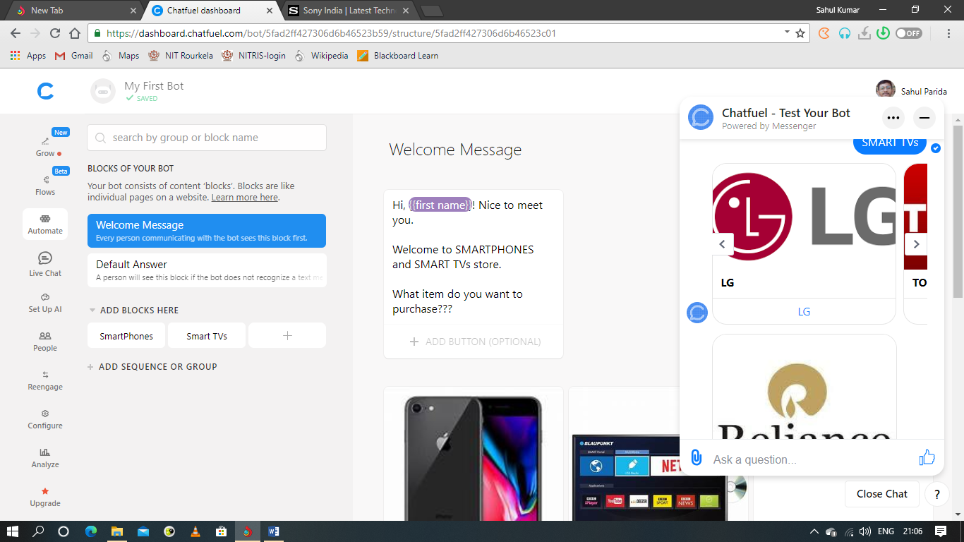

If user clicks LG, it gets redirected to LG official website.

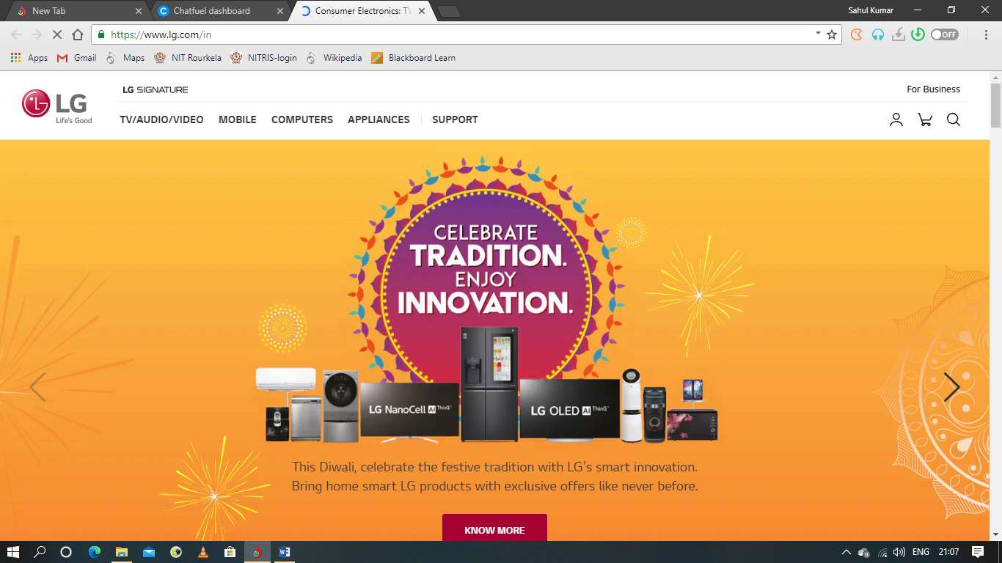

1. TOSHIBA

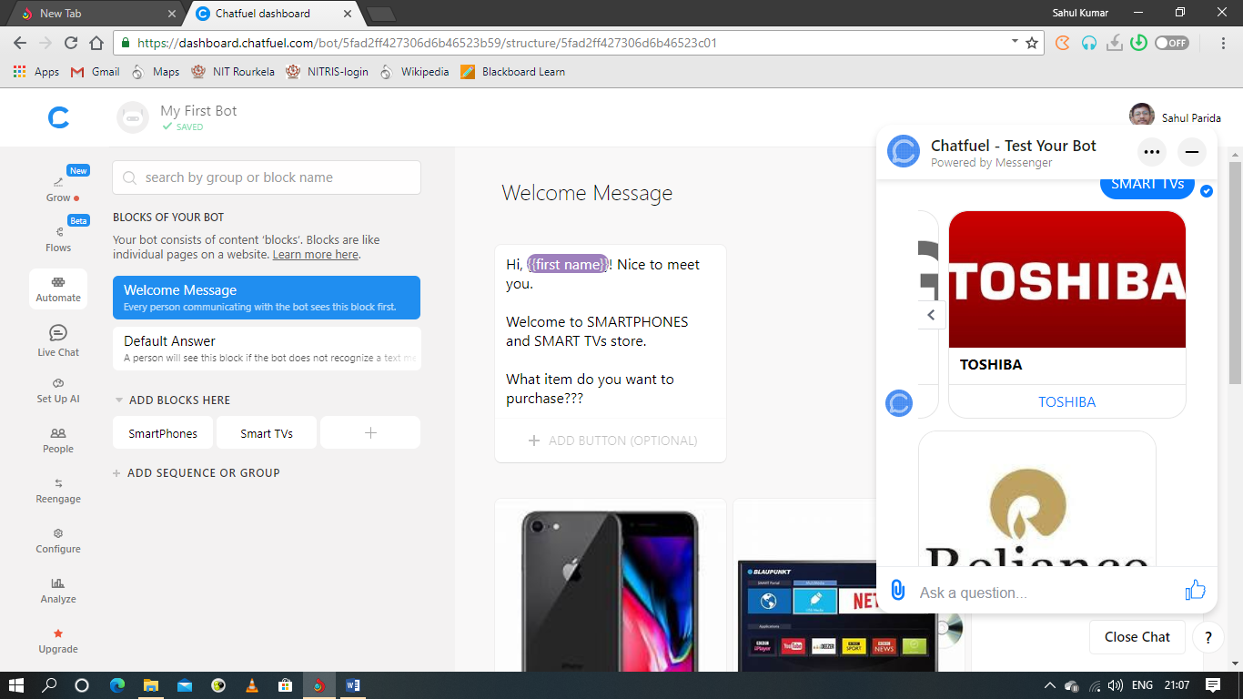

If user clicks TOSHIBA, it gets redirected to TOSHIBA official website.

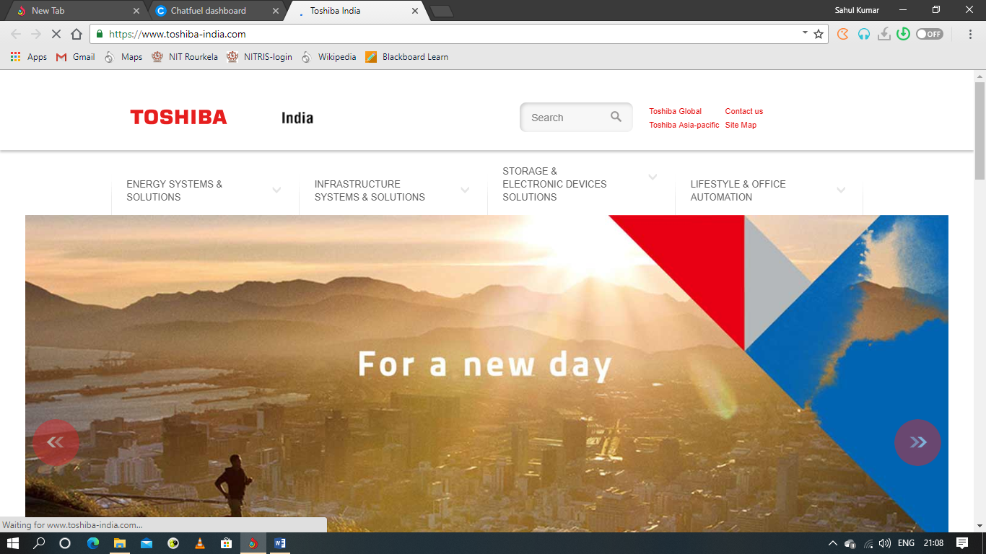

1. RELIANCE

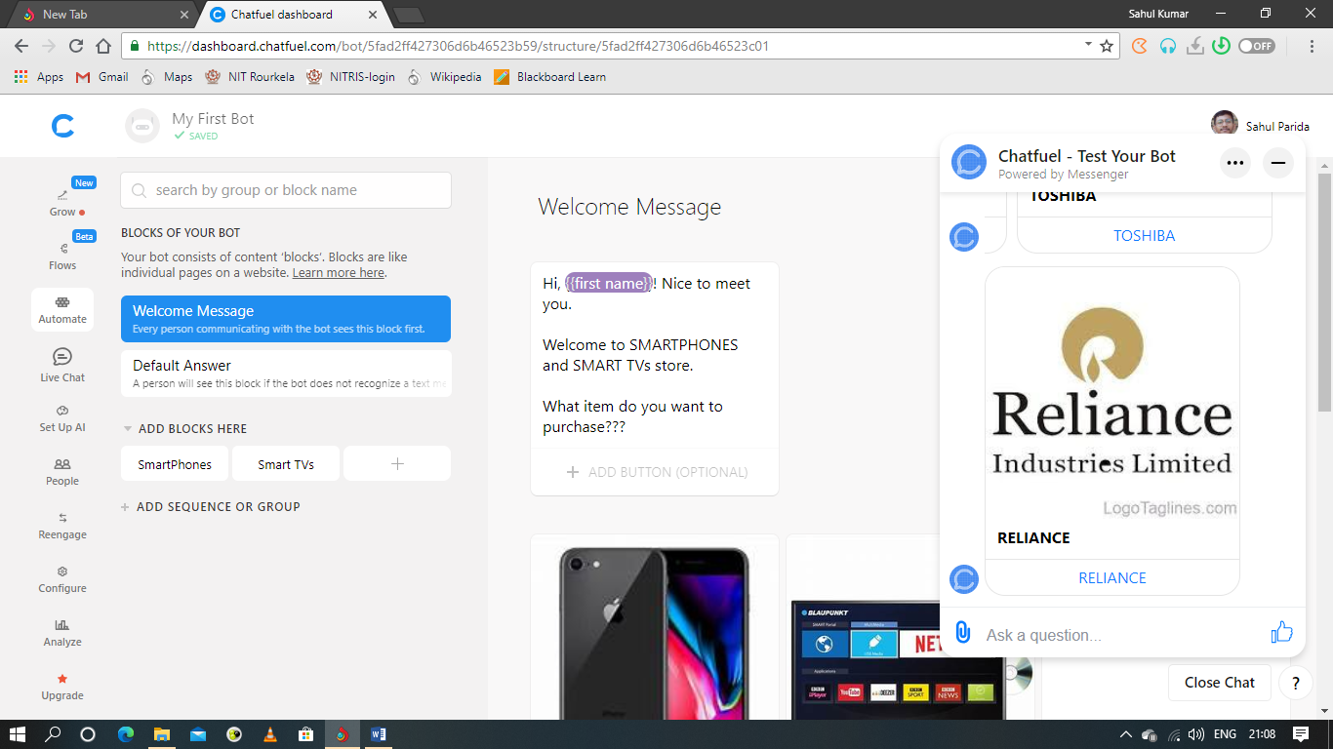

If user clicks RELIANCE, it gets redirected to RELIANCE official website.

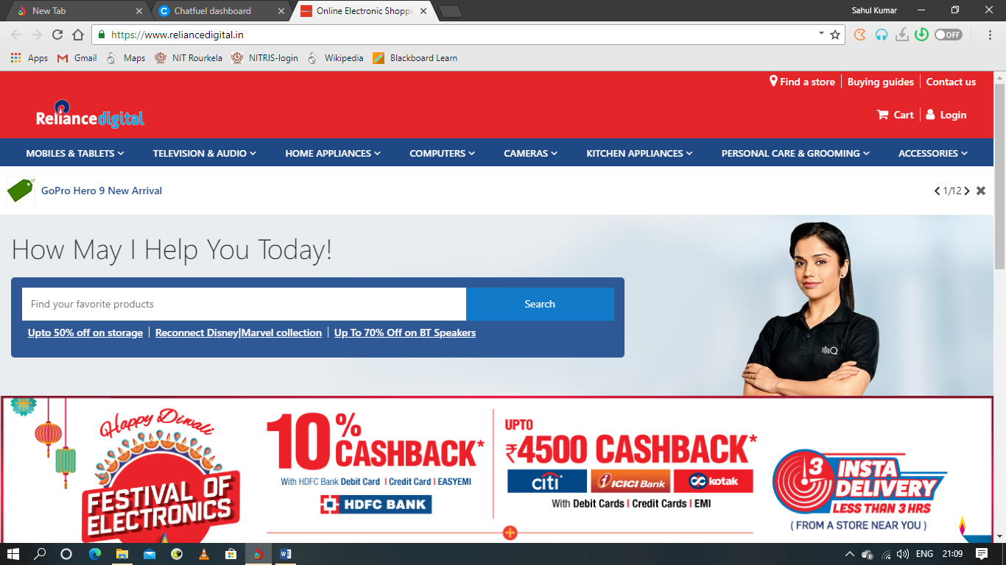

**Testing if the AI works properly**

**If user types how are you, it gets appropriate reply from chatbot.**

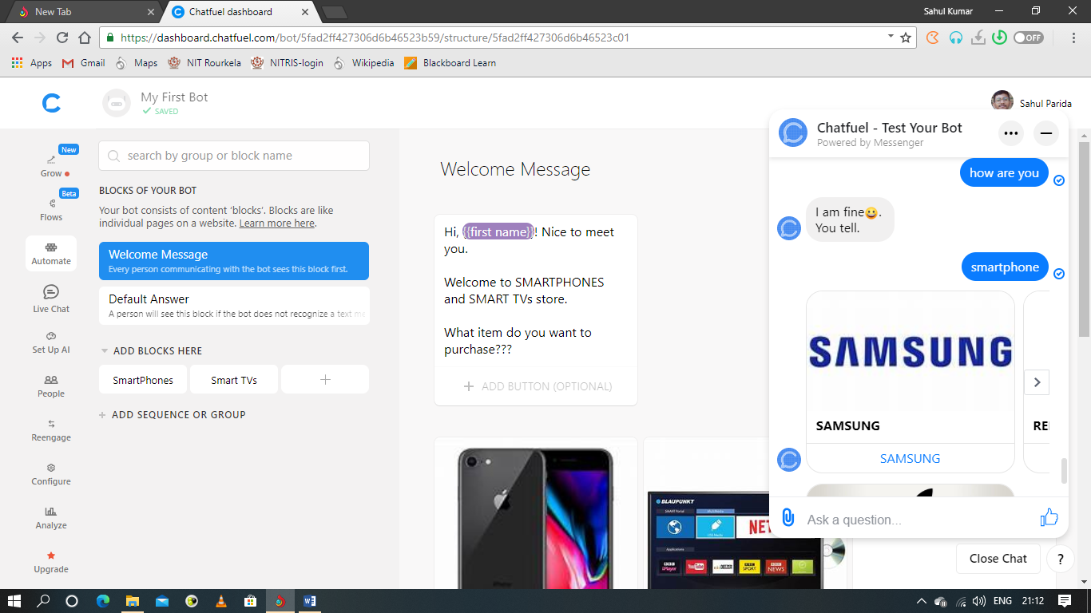

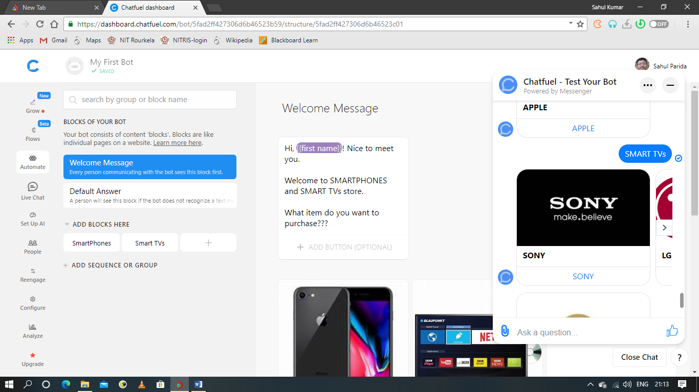

**If user types something inappropriate, chatbot replies the default answer as Could not understand.**

